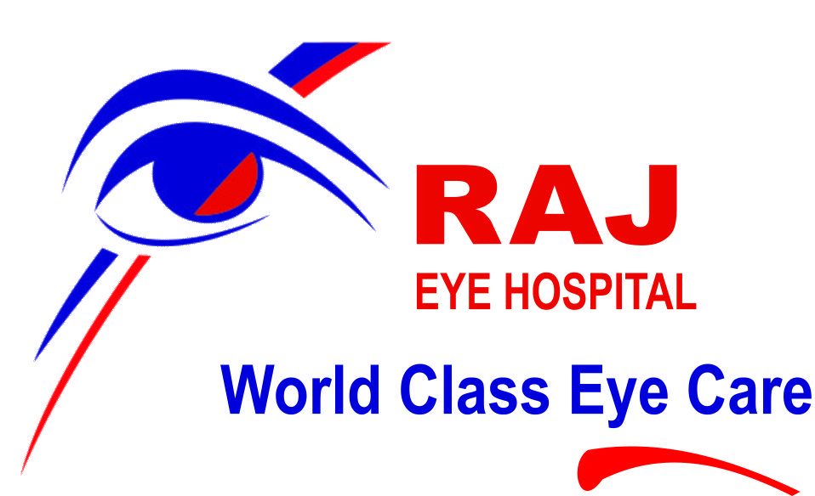

**Profile – Raj Eye Hospital**

*Certified by NABH- Highest standard of hospital, in patient safety and quality of care*

*[facility with equipment and departments, doctors, optometrists, management, photo gallery]*

Raj eye hospital ( NABH Accredited) was established on 4th January 1990 with the aim to provide modern, compassionate and quality eye care to all. It is situated in Gorakhpur, 300 KM east of Lucknow, UP, India, very well connected with air services.

Large number of people visit the hospital every day for consultation, diagnostic procedures and surgical procedures forFemto cataract, Femto Lasik, ICL, IOL, Cataract Surgery [without Stitch, Injection and Bandage], Diabetic Retinopathy, Vitreous Hemorrhage, Retinal Detachment, Glaucoma, Squint, Amblyopia,Ptosis,Eye Problem in Children, Corneal Transplant, Eye Injury, Orbital Tumors, Dacryocystitis, Botox Injection,.

Raj eye hospital has department of general ophthalmology, pediatric ophthalmology,Retina, Specialty of – Refractive Surgery, Orbit and Oculoplasty, Cornea, Glaucoma, Cataract. To serve poor people and educate masses we have department of community ophthalmology. To treat complicated cases we have latest equipment like femto second laser, red, green and blue laser, highest quality surgical and diagnostic gadgets in 5 storied building with constructed area around 25000 sq feet , at a land of 23000 sq feet, very close to bus and railway station, 6 km away from airport , modular operation theatres are equipped with Anesthesia workstation with ventilator and set for infants, defibrilator, monitors, operating microscopes , computers on lan for recording the patient details.

**SCOPE OF SERVICES- services provided by Raj Eye Hospital**

**1—Anaesthesiology- with the support of 2 anaesthesia work stations, and 2 anaesthetists, we are managing paediatric eye surgeries like-ocular trauma, lid surgery, lacrimal surgery, congenital cataract, traumatic cataract, glaucoma, squint, retinal detachment, orbital surgeries etc. we have defrillator for life saving in emergency along with life saving drugs and CPR team.**

**2-Ophthalmic emergency- Most of the doctors have residence in hospital campus and available 24 hours, big team of paramedics, makes the emergency management easier, mostly we get ocular injuries in children, which are operated on same day in most of the cases due to inhouse pathology and anaesthesia services. If required, we get CT or MRI adjacent to the raj eye hospital. Occasionally we get non surgical emergencies like lens induced glaucoma or acute narrow angle glaucoma, which are treated conservatively, availability of in house pharmacy makes it easier.**

**3-Comprehensive Ophthalmology- it deals with all kind of eye care, medical, diagnostic and surgical.**

**4-cataract services- very advanced setup equipped with femto laser, five phaco machines, 4 operating microscopes, advanced biometry equipment. Raj eye hospital is referral center for managing complicated cataract surgery like subluxated or dislocated cataract / IOL. It is doing surgeries for dropped nucleus, dropped IOL, scleral fixated IOL, multifocal and toric IOL, Piggy back IOL. Almost all cataract surgeries are done under topical anesthesia without any injection, pad, sutures and hospitalization.**

**5- Glaucoma Services-two glaucoma specialists and many other ophthalmologists are capable to detect and treat glaucoma cases. Raj eye hospital is very well equipped to detect, treat and monitor glaucoma patients. Since it is a silent killer of vision, we are proactive to find out narrow angle and open angle glaucoma when patient has no symptoms. We keep on sensitizing medical team and community for early detection of glaucoma. Apart from surgical facility we have OCT Angio, perimetry, gonioscopy contact and non contact, ERG & VEP, pachymetry, UBM, applanation tonometry. YAG Laser for peripheral iridectomy, Diode laser for cyclo photocoagulation, cyclo cryo-therapy are also available for glaucoma management.**

**6-Medical retina services – TWO VITREO RETINAL SURGEONS, trained by long term fellowship in vitreo retina are capable of managing medical retina of in house patients and referred patients from 150 km radius. Department is equipped with almost all kind of diagnostic equipment like FFA, OCT, OCT ANGIO, VEP, ERG, AND LASERS , INTRA VITREAL INECTIONS.**

**7- Surgical Retina services-TWO VITREO RETINAL SURGEONS, trained by long term fellowship in vitreo retina are capable of managing SURGICAL retina of in house patients and referred patients from 150 km radius. Department is equipped with almost all kind of diagnostic equipment like FFA, OCT, OCT ANGIO, VEP, ERG, AND LASERS , INTRA VITREAL INECTIONS, vitrectomy machine, cryo, operating microscope with biom and resight.**

**8-Oculoplasty and reconstructive surgery- two experienced surgeons trained by long term fellowship in oculoplasty, along with experienced paramedics are able to manage simple and complex surgeries quite well. Department has operating microscope, radio frequency cutter and cautery, endonasal viewing system to make DCR more predictable. Trauma, congenital defect, ptosis, age related lid defect are treated medically and surgically.**

**9-Orbit surgeries- all orbital surgeries are done by two oculoplasic surgeons, department is equipped with supporting staff and instruments of diagnostics and surgical. It has UBM, B scan, ophthalmometer,**

**10-Ocular Oncology (Radiational Oncology & Chemotherapy not available)- in eye, malignancy is dealt by multiple departments depending upon the location. For example if it is in lids or orbit then by oculoplasty department, if it is in cornea/ limbus then by cornea specialist, if in uvea or retina then by vitreo retinal surgeon. We have diagnostic & surgical facilities in ocular oncology but we don’t have radiational oncology and chemotherapy.**

**11-Pediatric Ophthalmology – we are managing good number of pediatric patients with the help of multiple specialties available raj eye hospital like – ROP clinic, ocular emergency, ocular trauma, ocular oncology, retina, cataract, squint, glaucoma, ptosis, congenital malformations. Department has RETCAM, ORTHOPTICS, OCULARIST, RFRACTIONIST trained in child care, team of 9 ophthalmologists trained in different specialties. It has play station for kids and feeding room .**

**12-Cornea services- 2 corneal surgeons registered in eye bank association of India and Uttar Pradesh human organ transplantation act[ HOTA] are doing good number of keratoplasty (therapeutic, optical penetrating/ lamellar) 2 to 4 every week. Tumours, trauma, keratoconus, lasik, c3r or cross linking, corneal infections, dry eye, ocular surface disorders are treated with the help of in house pathology, clinical specular microscope, eye bank specular microscope, topographer, non-invasive tear break up time, pupillometry, OCT, Lipiview&Lipiflow, femto laser, excimer laser and full range of other supportive tools.**

**13- Refractive Services – very advanced setup to evaluate and treat refractive disorders in children, adults and senior citizens. More than 50 optometrists trained in refraction are great support to the team of ophthalmologist. In raj eye hospital there are 12 refraction clinics, lasik, femtolasik, flap less laser vision correction, in house optical outlet, contact lens clinic. There are many happy patients who are happy to get rid of their glasses after Laser Vision Correction.**

**14-Uvea services- uvea services are dealt by 2 vitreo retinal consultants which is supported by optometrists and equipment like Bscan, UBM,OCTangio, FFA, Photo slit lamp, in house pathology. In some cases we have to outsource the services of some special pathological tests, CT, MRI , X-RAY etc.**

**15-Neuro ophthalmology- diseases of the optic nerve, chiasma, visual cortex, 3rd, 4th, 5th, 6th, and 7th cranial nerve, brain and muscles. Common disorders are abnormal eye movements, double vision, eye lids abnormalities (drooping, twitching, retraction, in action), optic neuritis, optic neuropathy, thyroid eye disease, one side vision loss. Department has ophthalmologists and optometrists to evaluate and treat with help of inhouse pathology, b scan, ophthalmometer, photo slit lamp, VEP, ERG, OCT ANGIO, Diplopia charting. In many cases CT,MRI& X RAY are outsourced. BOTOX injection is given for blepharospasm essential. If required surgical intervention is done.**

**16-Strabismus clinic- squint is detected in day to day comprehensive Ophthalmology, further evaluated in orthoptics, treated by refraction / amblyopia therapy ( 3 synaptophores ) patching, pencil push up exercise or squint surgery. Ideal time for convergent squint surgery is 4 months to 16 months of age, for divergent squint 4 years to 5 years to save the stereopsis [ binocular vision). Department is equipped with surgical set up along with anaesthesia support to do squint surgeries quite regularly and in early age.**

**17-Community Ophthalmology- in urban area we are doing free eye check up camps, awareness & educational materials for public in hospital and periphery, we are doing school screening camp to detect squint, refractive error, color vision defect, ROP screening camp, rural camps to detect cataract, glaucoma, squint, lacrimal diseases, corneal opacities to be treated by keratoplasty or laser. Due to huge number of optometrists, it is possible to do eye care at the door step in our surrounding community of 100 km radius. Our NGO wing is associated with national health mission and Aushman Bharat yajana.**

Almost all modern equipment are available in Raj Eye Hospital.

**1.   Equipment & Departments- available in the hospital.**

Hospital is equipped with world class state of the art equipments

**Operation Theatre-**  modular OT equipped with Operating Microscope- ZEISS – Lumera 700 with Calisto for marker less toriciol implantation, Lumera 700 with Resight, visu 210 with Xenon Light,mdo Zeiss, Topcon , Topcon with Biom,Appa and Labomed. All microscopes have HD quality video recording.

**Diagnostic cell-** battery of latest equipment-with Zeiss IOL Master 700, Tomey optical biometer, OCT nidek, OCT Topcon, OCT angio , HFA, Specular microscope, A Scan, B Scan, Fundus Fluorescein Angiography- digital from Topcon, CSO Topographer and aberrometer ,Gonioscopy, Applanation, Auto refractor, Keratometer, Non contact tonometer, digital photo slit lamp photographer,

**Cataract**- Femtosecond Laser for cataract surgery,6 PhacoMachines- Alcon centurian, Alcon constellation, Alcon Loreate,AMO Signature pro , Intuitive, Compact, ChakshuPhaco Systems.

**Vision Correction**by Excimer laser from Schwind,femto laser for lasik,HansatomeMicrokeratome, Schwind microkeratome, Pachymeter, Topographer, Zeiss OCT,Topcon OCT, Manual and Automated Keratometer. Equipments for ICL [Implantable Contact Lens]

**Glaucoma** unit with Zeiss - Humphery Visual Field Analyzer (HFA), Zeiss FDT, Alcon Pachymeter, Haggst Applanation Tonometer, Nidek- Non Contact Tonometer, Digital Disc Photographer, RNFL analysis by Zeiss OCT

**Retina unit** with- Alcon Constellation &AccurusVitrectomy System , Iridex Red Laser with Slit Lamp, LIO & Endo Laser Delivery Systems, Nidek Green Laser with Slit Lamp,LIO & Endo laser delivery systems, Topcon Digital FFA & ICG  , BIOM attachment for Zeiss& TopconOperating Microscope, Ultrasound B Scan,Resight Inverter Zeiss in Lumera . RETCAM for ROP screening.

**Cornea-** with Manual and Automated Keratometer, Anterior Segment OCT (Zeiss), Topographer, Photo Slit Lamp. Specular Microscope clinical(Topcon), Specular Microscope eye bank (konan), .Laminar Flow hood, LIPIVIEW and LIPIFLOW

**Eye Bank and Keratoplasty-** Registered in Eye Bank Association of India and under Human Organ Transplantation act

**Neuro ophthalmology –** Automated perimetry, Diplopia Charting, VEP & ERG, OCT ANGIO,

**Oculoplasty** necessary equipment for DCR, DCT, Ptosis, Orbitotomy, Cosmetic Correction of Post Traumatic Deformities, and lab for custom fit prosthesis.

**Contact Lens**

**Low Vision Aid**

**Pediatric Ophthalmology-**Synaptophore, Specialized Vision Testing Room, Feeding Room for young babies, equipments for Congenital Cataract, Squint and Ocular Injury Repair, Surgery under GA- anesthesia work station with accessory for infants.RETCAM for ROP screening

**Raj eye hospital is** considered as modern and model eye hospital in the region with experienced and well trained eye surgeons and optometrists along with supportive patient care staff. Few important objectives are ---

1. Provide eye care of **highest 'Quality'** to all segments of society.  
   (b) Provide **free or subsidized treatment** to those who cannot afford it.  
   (c) Encourage and **strengthen teaching and training programs**along with super specializations   
   to Doctors ,Ophthalmic Assistants, management and supportive human resource, through ongoing research and academic activities.  
   (d) Propagate the concept of 'Quality' Eye Care amongst professionals.  
   (f) Rendering **outreach ophthalmic services** in remote villages.  
   (g) **Create community awareness** about eye health problems.  
   (h) Contribute for the success of **National Program for Control of Blindness**.  
   (i) Prepare **Ophthalmic Assistants/Paramedics/Ophthalmologists** through teaching courses.  
   (j) Enhancing eye bank and **keratoplasty services.**

## MILESTONES

* **We brought many first QUITE EARLY in this region-**
* **SICS**
* **ECCE**
* **PHACO**
* **LASIK**
* **MODULAR OT**
* **FEMTO CATARACT**
* **FEMTO LASIK**
* **EYE BANK AND KERATOPLASTY & CORNEA SERVICES**
* **DRY EYE ASSESSMENT BY LIPI FLOW / VIEW**
* **RETINA MEDICAL AND SURGICAL AND UVEA**
* **GLAUCOMA SERVISES**
* **OCULOPLASTY , ORBIT,**
* **OCULARIST SERVICES [ AESTHETIC EYE/ ARTIFICIAL EYE]**
* **SQUINT AND PEDIATRIC SERVICES ALONG WIITH ORTHOPTICS**
* **OCT ANGIO**
* **VEP & ERG**
* **TRAINING TO Ophthalmologists and optometrist from INDIA and Abroad**
* - RETCAM For SCREENING of ROP (Retinopathy Of Prematurity)

**FUTURE PLAN-**

* 1- DNB Accreditation
* 2- Alliances with national and international eye care institutions.
* 3- Launching of more mobile units to reach remote rural areas.
* 4-. Awareness for Eye Donation
* 5-. School screening
* 6- ROP Screening
* 7- Association with other NGO's especially Indian Red Cross Society, Mahaveer International, Samarth, Lions Club, Rotary Club, cbm etc. for enhancement of awareness towards eye donations and eye care.
* 8- Association with paediatricians for better & timely eye care in children
* 9- Conducting planned surveys and researches, regarding the position of blindness in this region to aid in planning the prevention and treatment strategies. This will also be useful for the National Program for Control of Blindness - NPCB, Govt. of INDIA ...
* 10- Partnership with ophthalmologists, eye hospitals, optical centres and general hospitals.

**Doctors in Raj Eye Hospital-**

**Dr Anil Srivastava**

MBBS, MS, [IMS, BHU, VARANASI] CEO & Chief Ophthalmologist Specialist in Refractive Surgery & Glaucoma, , neuro ophthalmology

Pediatric Ophthalmology, cornea

MCI REG NO 30710

**Dr Deepesh Maurya**

MBBS, MS [MUHS, Nasik]

Specialist in Vitreo-Retina , Uvea and ROP [long term fellowship in retina- from Arvind Eye hospital]

MCI REG NO 27074

**Dr Shrikant Prasad**

MBBS, MS [PGI,MER, Chandigarh]

Specialist in Vitreo-Retina , Uvea and ROP [long term fellowship in vitreo-retina- from chitrakoot]

MCI REG NO 64459

**Dr. Vikas Gupta**

MBBS, MS [Manipal] Specialist in Cataract Surgery & General Ophthalmology

[long term fellowship in cataract & comprehensive ophthalmology from Raj Eye Hospital, Gorakhpur ]

MCI REG NO 58454

**Dr. Pramod Kumar Mahto**

MBBS, MS Specialist in Cataract Surgery & General Ophthalmology

[long term fellowship in cataract and comprehensive ophthalmology, from Lahan, Nepal ]

MCI REG NO 78083

**Dr Hareram Ojha**

MBBS, MS [ AKU PATNA]

Specialist in Oculoplasty& comprehensive ophthalmology

Long term fellowship in oculoplasty- Arvind Madurai

MCI REG NO 25380

**Dr Richa Srivastava**

MBBS, MS, FICO

Specialist in cataract, oculoplasty, comprehensive ophthalmology

Long term fellowship in oculoplasty

MCI REG NO

**Dr Richa Agrawal**

MBBS, MS,

Specialist in cataract & pediatric ophthalmology

3 years SR ship in pediatric ophthalmology, from Guru Nanak Eye Center, Delhi

**Dr Sunil Verma**

MBBS, MS, (Ophthalmology)

Specialist in Cataract &Glucoma

============================================================

**Dr Ankush *Weginwar***

MBBS, DOMS, DNB (Ophthalmology)

Specialist in Cataract &Vitreo Retina

**Dr Prasoon Pandey** {visits only on Friday}

MBBS, MS

Specialist in Cornea & Refractive Surgery

Long term fellowship in Cornea -Arvind Eye Hospital

MCI REG NO 81735

Supportive physicians

**Dr. Rajni Kant Srivastava**

MBBS, MD General Physician

**Dr. Himanshu Srivastava**

MBBS, MD Pathologist

**Dr. Raj Srivastava**

MBBS

Director, Raj Eye Hospital

**Dr. Deepak Modi**

MBBS, MD Anesthetist

**Dr. ArifBeig**

MBBS, MD Anesthetist

**Dr. Kapil Saxena**

MBBS, MD Anesthetist

**OPTOMETRISTS-**

RAJ KUMAR SINGH

V K Rai

REHANA PRAVEEN

EKTTA GUPTA

DANISH

GAUTAM

AMBRISH

NAVNEET

AMIT

RANJANA

SUBODH

JUFISHAN

VIKAS

PRITI

SUSHMA

NEELU

RAUNAQ

ERUM

SADAF

SADRE ALAM

GEETANJALI

SONU SAHANI

AKASH

NISHIT

ANSHIKA

**MANAGEMENT-**

MANAGING DIRECTOR- M N SRIVASTAVA

CEO & Chief Ophthalmologist – Dr Anil Srivastava

Director hr and finance - Rupam Srivastava

General Manager - D K Srivastava

Manager HR & Operations Vinay Pandey/ DD DWIVEDI

Manager – IT and CORPORATE RELATIONS Laxman Yadav[ Lucky]

Manager front desk&house keeping– Ashwani DIXIT

Manager Accounts – Manish Gupta

Manager medical records - Abhishek srivastava

Manager store - Ajay Srivastava

Manager Maintenance AND continued medical education - Neeraj Srivastava

Accountant yashin /

Accountant

Accountant Atul Srivastava

Photo gallery—

Raj Eye Hospital Front view facing North

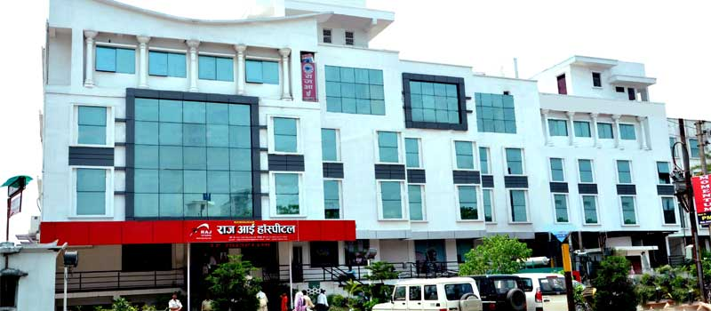

Waiting hall ground floor-

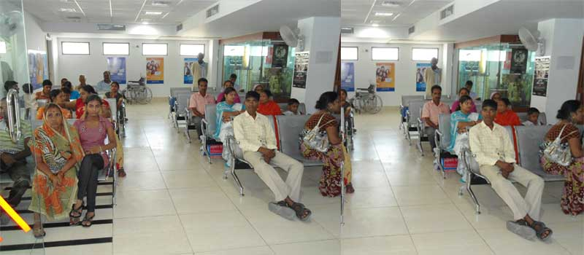

Waiting hall first floor-

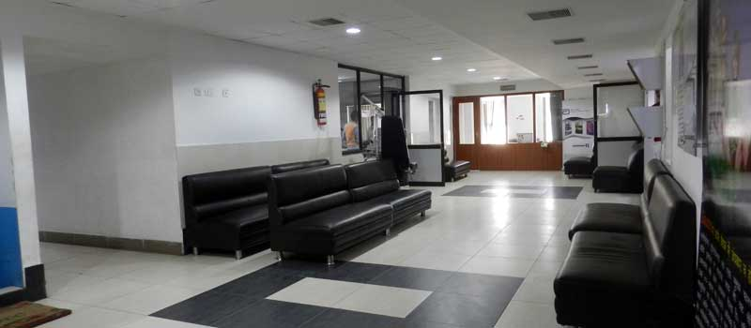

Waiting area and play station for children-

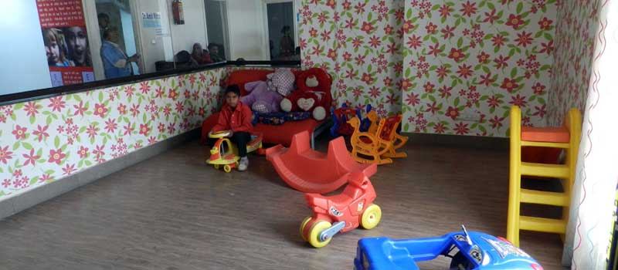

Waiting area for pre op patients-

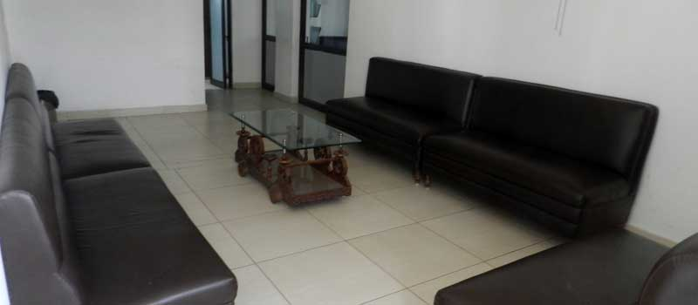

Opd

opd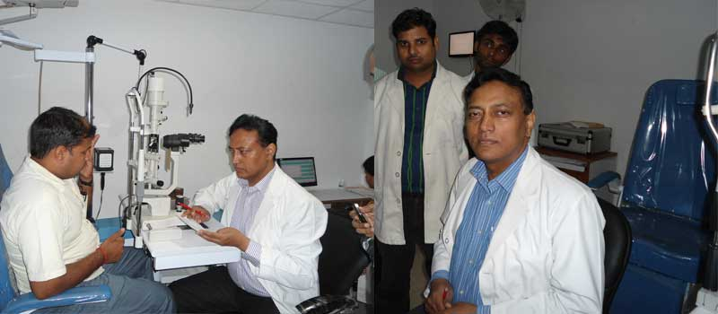

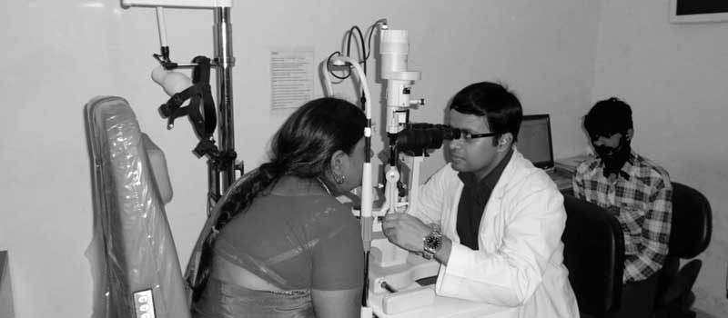

Operation theatre complex [total 5 operation theatres]

For retina, cataract, glaucoma, keratoplasty, oculoplastic surgeries, lasik

OT corridor

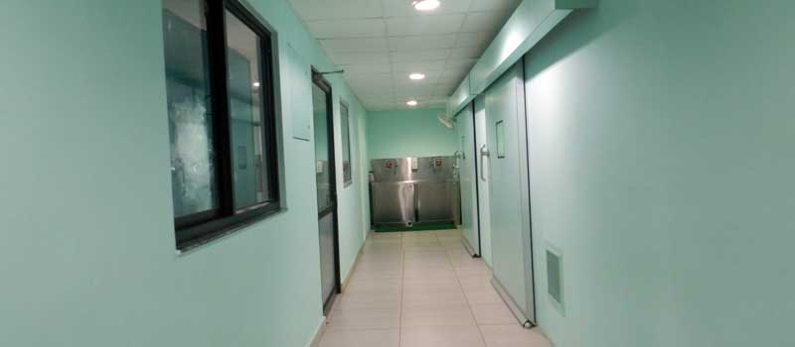

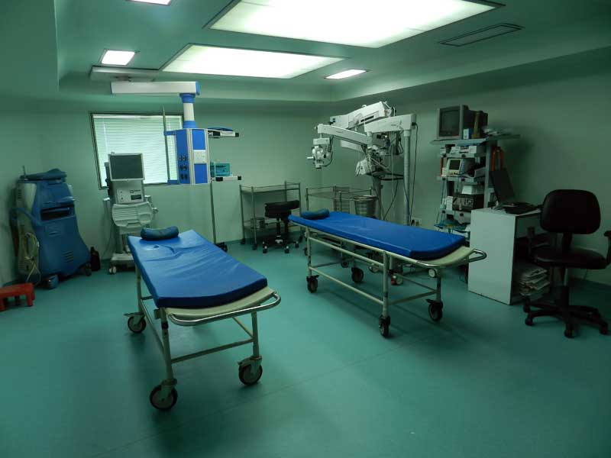

Surgery in raj eye hospital

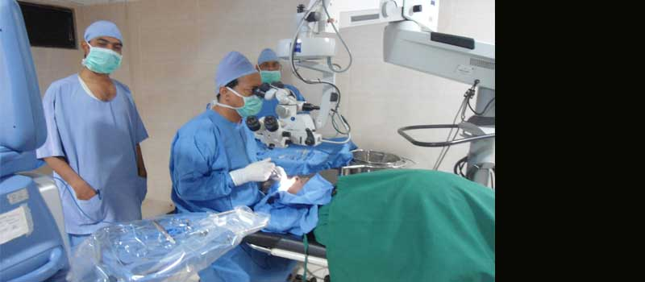

Surgery

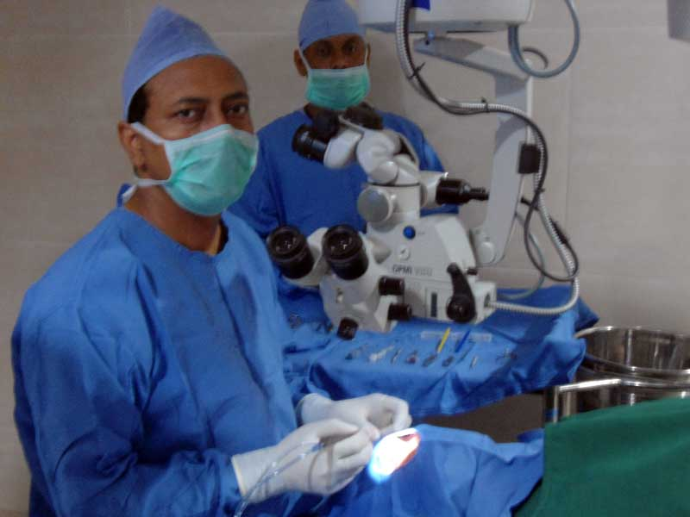

Modular ot

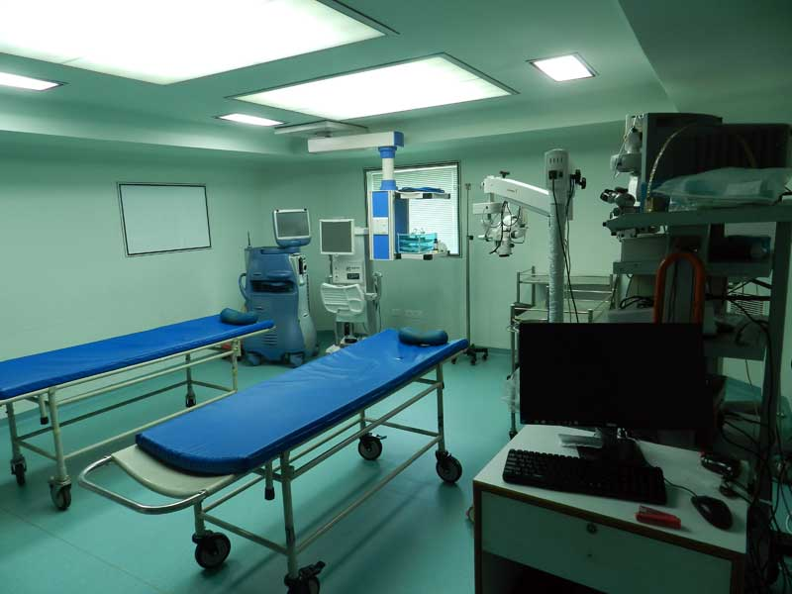

Optical show room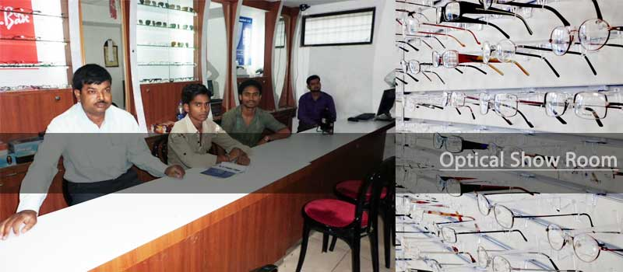

pharmacy

